

# Nokia X20 5G

## Type of device: Mobile

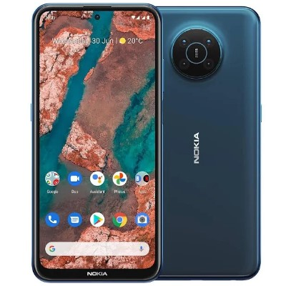

Actual Display Size : 6.67 inches

Button Type : Touchscreen

Operating System : Android

Version Number : Android 11

Network Capability : 3G,4G,5G

Year of Release : 2021

Average Price : $584 as of 13 07 2021

## Accessibility Features:

### Cognitive

* Additional Instructions
* Copy and Paste
* GPS
* Photo Telephone List
* Screen Timeout Disabled
* Simple Instructions
* Simple Reminders
* Simplify Display

Voice Notes

### Hearing Impairment and Deaf

* Allows for sign language communication
* Bluetooth or Wi-Fi
* Closed Captioning
* Front Facing Camera
* Text Messaging/SMS
* Vibrating Alerts - Adjustable
* Video Communications - Two-way

Visual Alerts - Incoming Calls

### Vision

* Battery Alert - Audible
* Bluetooth or Wi-Fi
* Braille Display Support
* Brightness Adjustable
* Dictation / Speech-to-Text
* Personalised Shortcuts
* Power Cue
* Screen Magnifier
* Screen Reader
* Text Size Adjustable
* Voice Control /Personal Assistant

Voiced Menus

### Speech

* Allows for sign language communication
* Bluetooth or Wi-Fi
* Messaging Options - Email
* Messaging Options - IM
* Messaging Options - MMS
* Predictive Text

SMS Personalisation and Reuse

### Physical

* Automatic Answer
* Bluetooth or Wi-Fi
* Dictation / Speech-to-Text
* Gesture Based Navigation
* Headset - plug connected
* Predictive Text
* Speaker-phone option
* Switch control option
* Voice Control / Personal Assistant
* Voice Recognition for Accessing Features

Voice Recognition for Dialling

## How and where to get it from?

You can buy this phone from [Nokia](https://www.nokia.com/phones/en_au/nokia-x-20), [JB Hi-Fi](https://www.jbhifi.com.au/search?query=Nokia%20x20%205G&page=1), [Officeworks](https://www.officeworks.com.au/shop/officeworks/search?q=Nokia%20X20%205G&view=grid&page=1&sortBy=bestmatch), [Kogan](https://www.kogan.com/au/shop/?q=Nokia+x20+5G), and other retailers.

## More information is available on:

[Nokia X20 Webpage](https://www.nokia.com/phones/en_au/nokia-x-20)

[Nokia X20 Specifications Webpage](https://www.nokia.com/phones/en_au/nokia-x-20/specs)

[Nokia X20 User Manual (PDF Download)](https://www.nokia.com/phones/en_au/support/api/pdf/nokia-x20-user-guide)